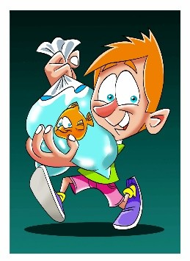How to Get a Goldfish

Evan had always wanted a pet, but he was allergic to dogs. His mother was allergic to cats. His father was afraid of rodents, and his little sister was afraid of reptiles. Evan was desperate.

"How about a goldfish?" he asked his parents.

They weren't thrilled about a goldfish, but they didn't exactly want to say no.

Instead, his father said, "You can have a goldfish, if you can figure out how to get one without it costing me any money."

"What a lousy family," Evan complained to his friend Tony that afternoon while they were sitting in Evan's room after school. But Tony wasn't paying any attention. He was looking at a pair of headphones on Evan's desk.

"What's wrong with those headphones?" he asked Evan. "Nothing," Evan said. "But I got two sets for my birthday." "Do you don't want these?" Tony said. "Can I have them?"

"Well, I'm not going to just give them away," Evan said. Then he had an idea. "Do you want to buy them?" he asked Tony.

"If I had any money I would just buy myself a pair," Tony said. "How about a trade? What do you want?"

"I want a fish bowl," Evan said.

The next day, Tony came over after school with a fish bowl. Evan didn't even ask him where it came from. He just handed over the headphones. He carefully rinsed out the bowl and filled it with water. Then he got his favorite shirt out of the closet, the one his friend Kevin was always admiring, and went to Kevin's house.

"I'll sell you this shirt for twenty dollar," Evan said. "I'll give you ten," Kevin said.

"Deal."

Evan took his ten dollars to the pet store, where he had just enough for one goldfish and a small packet of food. When he got home, he put his goldfish into its new home and sprinkled a little food onto the surface of the water. The goldfish gobbled it up. Evan was proud of himself. He had managed to get himself a goldfish, and nobody in his family could complain because none of them even knew that it was there.